# Create & Publish Project Templates for Photino Sample Applications

Mike Yeager

Saturday, February 6, 2021

## Overview

Photino project templates create bare-bones sample applications for various Photino project flavors such as .NET (plain html), Angular, React, Vue, and Blazor. Installing the project templates for Visual Studio 2019, the dotnet CLI and/or VS Code is the easiest way to get up and running creating Photino apps for .NET 5.

Project templates for Visual Studio are not the same as project templates for the dotnet CLI. Each must be maintained separately.

Visual Studio templates are installed as extensions from Visual Studio Gallery <https://marketplace.visualstudio.com/items?itemName=TryPhotino.PhotinoSamplesVSExtension>.

dotnet CLI (also for VS Code) project templates are installed from NuGet packages <https://www.nuget.org/packages/TryPhotino.VSCode.Project.Templates>

This document is designed to show you how to update the VS extension and NuGet package with new versions of the sample application project templates. Project templates are created from the projects in the Photino.Samples solution.

## Visual Studio (2019)

### Create/Update Project Templates

1. Open the Photino.Samples solution (source code can be found at <https://github.com/tryphotino/photino.Samples>)
2. Update the samples as required and ensure they build and run correctly
3. From the Project menu, select Export Template…
4. For each project, enter description as: “Photino.XXX Sample application with XXX UI”
5. Set icon and preview images if you have them

Zip files are written to:

* *C:\Users\xxxx\Documents\Visual Studio 2019\Templates\ProjectTemplates*
* *C:\Users\xxxx\Documents\Visual Studio 2019\My Exported Templates*

Project templates will now be available on your dev machine and you can copy the .zip files from the My Exported Templates folder to the ProjectTemplates folder on other machines to ‘install them’ for testing.

### Upload VSIX Extension to Visual Studio Gallery

NOTE: Ensure you have the Visual Studio Extension Development workload installed to create a VSIX

1. Open the PhotinoSamples.VSExtension solution (source code can be found at <https://github.com/tryphotino/PhotinoSamples.VSExtension>)
2. Copy the .zip template files created above to the PhotinoSamples project folder
3. Add any new .zip files to the project and set the Copy to Output properties to Copy Always
4. Open the source.extension.vsixmanifest file and edit the Metadata properties
5. On the Assets tab, add each new .zip file as a Microsoft.VisualStudio.ProjectTemplate file
6. Update ReleaseNotes.txt putting changes since the last version at the top
7. Save vsix.extension.manifest changes and build the project
8. A new Visual Studio instance will open with the templates installed for testing. You will likely see 2 copies of each template since there is already a copy in the *\ProjectTemplates* folder from the steps above.
9. Sign in to <https://marketplace.visualstudio.com> with [tryphotino@outlook.com](mailto:tryphotino@outlook.com) Microsoft ID
10. Click the “Publish Extensions” link

### To Install and Use Extension from Visual Studio

Open Visual Studio 2019, click on the Extensions menu, and choose Manage Extensions… From the Online tab, search for Photino, select Photino Sample Project Templates and click Download.

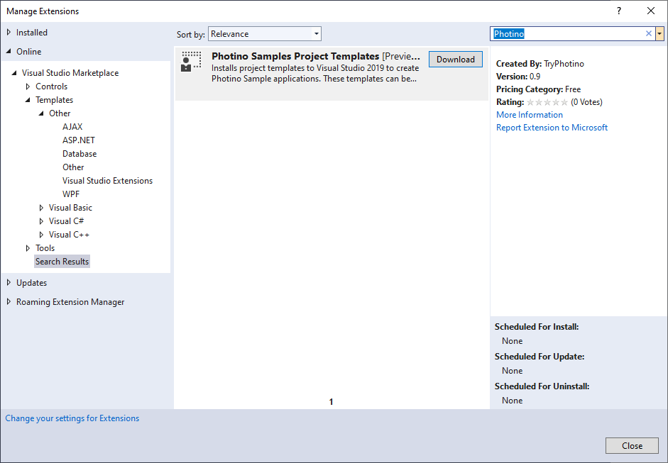

Re-start Visual Studio to install the extension. Create a new project and search for Photino in the project templates screen.

Run the new project to ensure the template worked correctly.

## dotnet CLI and/or Visual Studio Code

### Create/Test A Single Project Template

1. Open a command prompt in the ….*\Photino\photino.PhotinoSamples.VSCodeTemplates\working\templates* folder

(source code can be found at <https://github.com/tryphotino/PhotinoSamples.VSCodeTemplates>)

1. Copy the latest versions of the source code for the projects in the Photino.PhotinoSamples solution into the matching folders in *PhotinoSamples.VSCodeTemplates*
2. Type **dotnet run** at the prompt to ensure each project builds and runs correctly
3. Verify the contents of the template.json files in the *.template.config* sub folders for each project
4. Delete the bin and obj folders, any, .gitignore or other files that should not be part of the templates (do not delete the *.template.config* folders)
5. From each project folder type **dotnet new -i ./** to install the template on your machine
6. Navigate to the ….*\Photino\photino.PhotinoSamples.VSCodeTemplates\test* folder and delete all contents. If there is no *\test* folder, create one.
7. Type **dotnet new photinoangular** (the shortName from the template.json file for each project) to test each template
8. Type **dotnet run** to test that the project is created correctly
9. Delete the contents of the test folder after testing each template
10. Type **dotnet new -u the ….*\Photino\photino.PhotinoSamples.VSCodeTemplates\working\templates\<project>*** to uninstall each template

### Pack All Project Templates and Upload to NuGet.org

1. Ensure all individual templates are up to date and work correctly (per single template above)
2. Open VS Code to the ….*\Photino\photino.PhotinoSamples.VSCodeTemplates\working* folder
3. Edit the templatepack.csproj file to set version number for the NuGet package
4. From a terminal window type **dotnet pack** to create the NuGet package
5. Note that you will likely see warnings. This is normal.
6. Assuming you have NuGet Package Explorer installed from the Microsoft Store, double-click on the NuGet package to inspect, update, and verify it
7. You must fill in some of the data manually as dotnet pack does not work with the following tags
   1. Owners TryPhotino
   2. ProjectUrl <https://tryphotino.io>
   3. Copyright TryPhotino 2020
8. Log into <https://nuget.org> with your Microsoft ID
9. Click the Upload link and manually upload the package update

### To Install and Use Templates from NuGet.org

Type **dotnet new -i TryPhotino.VSCode.Project.Templates** (the NuGet package name) to install the templates.

Type **dotnet new photinoangular** (or other sample short name) to create a new project using that template.

Type **dotnet new -l** to list all install project templates or **dotnet new -u** to list details about each template.

Type **dotnet new -u TryPhotino.VSCode.Project.Templates** to uninstall the templates.

### Sources:

[Create a project template for dotnet new - .NET | Microsoft Docs](https://docs.microsoft.com/en-us/dotnet/core/tutorials/cli-templates-create-project-template)

[Create a template pack for dotnet new - .NET | Microsoft Docs](https://docs.microsoft.com/en-us/dotnet/core/tutorials/cli-templates-create-template-pack)